ST BENEDICT’S COLLEGE


SUBJECT |  | English |  | DATE |  |  | 14 November, 2016
GRADE |  | 11 |  | MARKS |  |  | 90
EXAMINER |  | Mrs Nichas, Mr de Reuck, Mrs Oosthuysen, Mrs Leeburn |  | MODERATOR |  |  | Mrs Nichas
NAME |  |  |  | DURATION |  |  | 2 ½ hours
CLASS
LOW ORDER | 58% |  | HIGH ORDER |  | 42%

INSTRUCTIONS
1. This question paper consists of 13 pages. Please check that your question paper is complete.
2. Utilise your reading time carefully.
3. Ensure that you number your questions as indicated on the question paper.
4. Begin each QUESTION on a new page. Do not copy down headings for your answers. Copy down only the question numbers, making sure they are accurate. You may answer the questions in whatever order you wish, but number your answers exactly as the questions are numbered.
5. Do not hesitate to give your own judgements. Attempt to create space in which your own voice is evident. The examiners will judge your answers on your understanding of, and insight into given texts, and will also assess the competence with which your answers are expressed.
6. Be guided by the number of marks allocated to each question. Aim at concise answers that give relevant information.
7. Answers must be written in the Answer Book supplied.
8. It is in your own interest to write legibly and to present your work neatly.

Question | 1 | 2 | 3/4 | 5 | 6 | Total | %
Possible Marks | 26 | 10 | 26 | 15 | 13 | 90
Marks Achieved

question 1 – comprehension 26 marks
Read TEXT1 and answer the questions that follow.

1.1 David Brooks writes a weekly newspaper column for the New York Times. Judge whether the opening sentence of TEXT 1 is appropriate by considering the content and purpose of the column. (3)
1.2 Explain the meaning of the idiom, “that rings true to me” in paragraph 2. (1)
1.3 Quote an example of informal language used in paragraph 3 and explain its effectiveness. (2)
1.4 What is the writer implying about young people when he refers to the ‘orchid generation’? (2)
1.5.1 Examine the use of diction in paragraph 8. Explain the difference in the connotations of the words ‘hard’ and ‘ardent’ in the context of the paragraph. (2)
1.5.2 Identify the idiomatic expression used in paragraph 9 that would support your answer to 1.5.1 and explain how this contradicts the writer’s earlier assertions about young people. (3)
1.6 The writer uses the expression, ‘means inspired by an end’ in paragraph 11. How does this meaning differ from the original expression, ‘means to an end’ and why does the writer choose the first expression? (3)
1.7 What is the effect of the use of repetition and commas in paragraph 12? (2)
1.8 Do you agree with the writer’s view in paragraphs 16-18 regarding mental toughness in people today? Explain your answer with close reference to these paragraphs. (3)
1.9
What millennials are most famous for besides narcissism is its effect: entitlement. If you want to sell seminars to middle managers, make them about how to deal with young employees who e-mail the CEO directly and beg off projects they find boring. English teacher David McCullough Jr.’s address last year to Wellesley High School’s graduating class, a 12-minute reality check titled “You Are Not Special,” has nearly 2 million hits on YouTube. “Climb the mountain so you can see the world, not so the world can see you,” McCullough told the graduates. He says nearly all the response to the video has been positive, especially from millennials themselves; the video has 57 likes for every dislike.
(Joel Stein, Time, 2013)

Considering the extract above and the information from TEXT 1, how would Joel Stein answer David Brooks if the following question was asked of him, ‘Do young people (millennials) today have the strength of character to succeed?’ Your answer needs to make reference to both texts. (4)

question 2 – summary 10 marks
Refer to TEXT 2, “Humans have in-built time limit” and answer the following question.

Text 2 asks some interesting ethical questions regarding the new research claiming we may soon hit a natural lifespan limit of 115 years. The questions are: ‘Can we change that?’ and ‘Should we?’
By summarising TEXT 2 in not more than 90 words, write an overview of the research in this area for a class report. Your summary should focus on the aspects of the text that support your stance to the questions above.

- Your response must be in the form of one coherent paragraph.
- You must use full sentences.
- Your language use must be accurate and in an appropriate register.
- Provide an appropriate title which is included in your word count.
- Provide an accurate word count at the end of the summary.
- Use your own words. 'Cutting and pasting' of information is not acceptable.

question 3 – seen poetry 26 marks
Read the poem Release, February 1990 by Lynne Bryer and answer the questions that follow.
Release, February 1990 (Lynne Bryer)
He emerged, walked free
Looking like an ordinary, sweet grandfather
From the Eastern Cape:
Those lovely old men we children knew
Were wise and saintly, 5
Walking down the streets
In ancient suits, greatcoats
From the First Wold War. We always greeted,
An exchange both courteous and right.

Grown older, we salute Mandela. 10
Not the bogeyman whose face
was a forbidden sight (abroad,
we looked in libraries); nor charismatic
warrior, giving tongue in blood and flame.

The heavens did not fall. 15
But then, for days before, the mountain
(struck by lightning) burned,
the dark alive with crimson snakes
writhing on air, black elevation of the night.

Confirmation came 20
less from our eyes, watching the images that flew
about the world, than from the way we felt:
elated, cool, not doubting this was true,
the destined time and place.

This is the way messiahs come – 25
when time can stand no more delay,
and people throng the streets, mill in the square,
climb trees to see.
Even the soldiers,
Nervous in the mob (since they alone are armed, 30
and so not free) are part of the convergence,
the dislocated, sudden calm of knowing:
This was the way it had to be.

3.1 Contrast the perceptions of Mandela in stanzas one and two. Quote to support your answer. (2)
3.2 Explain the reference to fate in the poem and its link to Mandela as a messiah. (3)
3.3 Examine the diction in stanzas 3 and 4. How does the diction show a shift in tone in these stanzas? (3)
3.4 Explain the meaning of the paradox in line 32 and how it affects the message of the poem as a whole. (2)

question 4 – unseen poetry
RRead the poem Blessing by Imtiaz Dharker and answer the questions which follow.
Blessing (Imtiaz Dharker)
The skin cracks like a pod.
There never is enough water.

Imagine the drip of it,
the small splash, echo
in a tin mug, 5
the voice of a kindly god.

Sometimes, the sudden rush
of fortune. The municipal pipe bursts,
silver crashes to the ground
and the flow has found 10
a roar of tongues. From the huts,
a congregation: every man and woman
child for streets around
butts in, with pots,
brass, copper, aluminium, 15
plastic buckets,
frantic hands,

and naked children
screaming in the liquid sun,
their highlights polished to perfection, 20
flashing light,
as the blessing sings
over their small bones.

4.1 In light of the content presented in the poem, why is the title effective? Quote from the poem to support your answer. (2)

4.2 Provide an example of religious imagery from the poem. Discuss the connotations of the image you have chosen. (2)

4.3 Examine the figurative language in stanza 1. How do the use of personification and the simile emphasise the lack of water in the region? (2)

4.4 How does the structure of stanza 3 reflect the action described in the poem? (3)

4.5 Which of the following visuals best capture the mood of stanza 4? Quote from stanza 4 to support your answer. (3)

Visual A Visual B



4.6 Considering Release and Blessing, discuss the nature of hope as it is presented in both the poems. Your answer needs to include a reference to who is seen to be hopeful and for what reasons. You also need to substantiate your reasoning with careful reference to both poems. (4)

QUESTION 5 – VISUAL LITERACY 15 MARKS
Refer to TEXTS 3, 4, 5 and 6 then answer the questions that follow.

Refer to TEXT 3
5.1 Provide a justified reason for the areas which make the most use of child labour. In your answer also identify whose interests are being served in the creation of this map. (3)

Refer to TEXT 4
5.2 Identify 2 possible long-term consequences of child labour on the emotional, social and economic development of children affected by these circumstances. Substantiate your answer. (4)

Refer to TEXTS 5 and 6
5.3 How is the reader positioned to view the targeted company in these texts? Provide visual and verbal clues from each of the texts to justify your answer. (5)
5.4 Discuss which text (TEXT 5 or TEXT 6) you believe would have the most impact in wealthy societies. Justify your answer. (3)

question 6 – textual editing 13 marks
Read text 7 and answer the questions that follow.

6.1 How does the writer’s use of pronouns in paragraph 1 position the reader? (2)
6.2 Identify and correct the grammatical error that occurs in the last sentence of paragraph 2. (2)
6.3 Correct the TWO spelling mistakes in paragraphs 3 and 5. (2)
6.4 Provide a synonym for the word ‘immune’. (paragraph 3) (1)
6.5.1 Rewrite the following sentence in the passive voice: “These real people are facing real problems.” (1)
6.5.2 Why is this particular sentence more effective when written in the active voice? (2)
6.6 Identify the syntax (sentence construction) error in sentence 1 of paragraph 6. (1)
6.7 Identify and correct the grammatical error in sentence 2 of paragraph 6. (2)
TEXT 1:
Making Modern toughness (David Brooks)
- When I ask veteran college teachers and administrators to describe how college students have changed over the years, I often get an answer like this: “Today’s students are more accomplished than past generations, but they are also more emotionally fragile.”
- That rings true to me. Today’s students are amazing, but they bathe one another in oceans of affirmation ad praise, as if buttressing one another against some insecurity. Whatever one thinks of the campus protests, the desire for trigger warning sand safe spaces does seem to emanate from a place of emotional fragility.
- And if you hang around the middle aged, you hear a common story line to explain the rise of the orchid generation. Once upon a time, the story line goes, kids were raised in a tough environment. They had to do hard manual chores around the house and they got in fights on the playground. Then they went off to do gruelling work in the factory or they learned toughness and grit in the military.
- But today, helicopter parents protect their children from setbacks and hardship. They supervise every playground conflict, so kids never learn to handle disputes or deal with pain.
- There’s a lot of truth to that narrative, but let’s not be too nostalgic for the past. A lot of what we take to be the toughness of the past was really just callousness. There was a greater tendency in years gone by to wall off emotions, to put on a thick skin – for some men to be stone-like and uncommunicative and for some women to be brittle, brassy and untouchable.
- And then many people turned to alcohol to help them feel anything at all.
- Perhaps it’s time to rethink toughness or at least detach it from hardness. Being emotionally resilient is not some defensive posture. It’s not having some armour surrounding you so that nothing can hurt you.
- The people we admire for being resilient are not hard; they are ardent. They have a fervent commitment to some cause, some ideal or some relationship. That higher yearning enables them to withstand setbacks, pain and betrayal.
- Such people are, as they say in the martial arts world, strong like water. A blow might sink into them, and when it does they are profoundly affected by it. But they can absorb the blow because it’s short term while their natural shape is long term.
- There are moments when they feel swallowed up by fear. They feel and live in the pain. But they work through it and their ardent yearning is still there, and they return to an altered wholeness.
- In this way of thinking, grit, resilience and toughness are not traits that people possess intrinsically. They are not tools you can possess independently for the sake of themselves. They are means inspired by an end.
- John R. Lewis may not have been intrinsically tough, but he was tough in the name of civil rights. Mother Teresa may not have been intrinsically steadfast, but she was steadfast in the name of God. The people around us may not be remorselessly gritty, but they can be that when it comes to protecting their loved ones, when it comes to some dream for their future self.
- People are much stronger than they think they are when in pursuit of their telos, their purpose for living. As Nietzsche put it, “He who has a why to live for can bear almost any how.”
- In short, emotional fragility is not only caused by overprotective parenting. It’s also caused by anything that makes it harder for people to find their telos. It’s caused by the culture of modern psychology, which sometimes tries to talk about psychological traits in isolation from moral purposes. It’s caused by the by the ethos of the modern university, which in the name of “critical thinking” encourages students to be detached and corrosively sceptical. It’s caused by the status code of modern meritocracy, which encourages people to pursue success symbols that they don’t actually desire.
- We are all fragile when we don’t know what our purpose is, when we haven’t thrown ourselves with abandon into a social role, when we haven’t committed ourselves to certain people, when we feel like a swimmer in an ocean with no edge.
text 2:
- If you really want people to be tough, make them idealistic for some cause, make them tender for some other person, make them committed to some worldview that puts today’s temporary pain in the context of a larger hope.
- Emotional fragility seems like a psychological problem, but it has only a philosophical answer. People are really tough only after they have taken a leap of faith for some truth or mission or love. Once they’ve done that they can withstand a lot.
- We live in an age when it’s considered sophisticated to be disenchanted. But people who are enchanted are the real tough cookies.
New York Times, August 30, 2016
Humans have in-built time limit
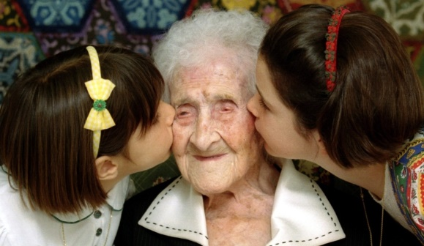
Happy 120th!: Jeanne Calment celebrates her birthday. © Jean-Paul Pelissier
For decades, people in the developed world have enjoyed ever longer lives. But according to new research, we may soon hit a natural limit of 115 years. Can we change that? Should we?
As a girl she met Vincent van Gogh. In her later years she produced a rap album. When Jeanne Calment died in 1997 at the age of 122, she set a record for the longest ever lifespan. According to a new study it could stand for a long time.
Researchers have found that people in the developed world tend to live longer once they hit 70 than they did a century ago. For over-100s, however, there has been far less improvement. The study concludes that humans have a maximum lifespan of around 115 years. Even with all the medical treatment in the world, our genes are unlikely to let us live beyond that.
The brevity of life has always fascinated us. Ancient texts are peopled with characters who defy death, from the Bible’s 969-year-old Methuselah to the family of bickering gods in Homer. For most of our history we interpreted extended life through religious concepts like the afterlife — it was not a literal goal.
In the 20th century that changed. Medicine made rapid progress: the average lifespan of a first-world citizen shot up from 47 in 1900 to 80 in 2016. The science of ageing developed. Experts began to talk of ‘Methuselah genes’, which determine our lifespans. This prompted the question: what if we could change our genes?
Some refuse to accept the idea of a ‘lifespan limit’ – and are spending big money to prove their point. Google has opened Calico, a mysterious lab specialising in longevity research. A Silicon Valley entrepreneur has set up the Palo Alto Prize, offering $1m to anyone who can ‘hack the code’ — that is, our genes. Dozens of teams have applied.
The exact mechanics of ageing remain unclear, and researchers are studying it from all different angles. But they are united by one belief: rather than invest in cures for specific diseases, we should focus on delaying old age. This will lead to healthier, longer lives — even (whisper it) immortality.
Yet as this field has grown, so have the ethical concerns around it. Those in the field are often called ‘optimists’, as if longer lifespans are unarguably good. But not everyone agrees…
Ageing is not a disease, say some. It is what gives life meaning. Our in-built expiry date spurs us on to achieve things and enjoy each day. Homer’s gods may be energetic and beautiful, but they lead a frivolous existence. Practical problems aside, extending our lifespan would undermine our very humanity.
Hang on, reply others. Our lifespans are almost double those of our great-grandparents, yet we are no more depressed or frivolous than they were. As our lives get longer, our capacity to fill them with meaning grows. Think of the things we could achieve, the places we could visit, if we had centuries…


Text 3: The Countries and Goods which use Child Labour

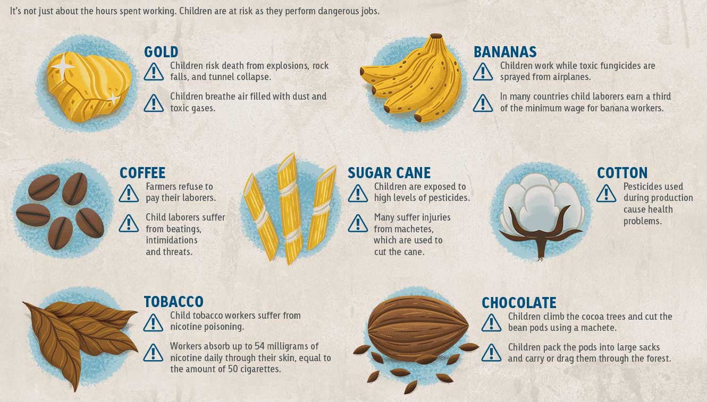
TEXT 4: The Dangers of Child Labour

TEXT 5:
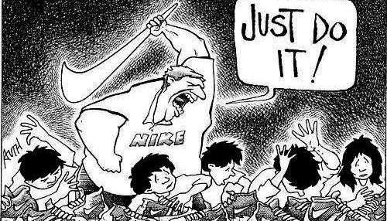


TEXT 6:

Text 7:
Watch Less Television!
1. Life is meant to be lived, not watched. To get started living your own life rather than watching others live theirs, consider its impact on your life. Here are a few reasons to give it up:
2. It is influencing your worldview. Anybody who has ever been a policeman, a lawyer, a psychiatrist, an ER doctor, or an FBI agent will attest to the truth that television does not accurately portray their life. In almost all aspects, television rarely depicts the world and life accurately. Too much television results in disillusionment about what to truly expect from the world around us.
3. It is influencing your spending habits. If you think you are immune (or too smart) to be influenced by the power of advertisments, you are wrong.
4. It is taking you away from the real people all around you. The characters on television are not real. They are thought up in an office building and given life on a piece of paper. In contrast, you are surrounded everyday by real people living real lives. These real people are facing real problems, they need you and you need them.
5. It is robbing you of precious mental energy. When you’re television is on, your concentration is held hostage. Your mental energy is drawn into the screen and your ability to control it is given up.
6. It results in less satisfaction and fulfilment with life. According to the Journal of Economic Psychology, TV viewers reports lower life satisfaction, higher material aspirations, and more anxiety.
7. Its opportunity cost is too great. Calculate the hours you’ve spent watching T.V…. That’s time you could have spent exercising, eating a meal together, entertaining, enjoying nature, meditating, enjoying a hobby, reading a book, or fulfilling a dream.
- Adapted from http://www.becomingminimalist.com/ten-reasons-to-watch-less-television/

